Process of Uninstalling Oracle Database 19c
It’s a 5-step process to uninstall Oracle database 19c.
These 5 steps are –
- Delete the Environment Variable
- Delete the Registries
- Restart the Machine
- Delete Oracle Home Users and Groups
- Delete Oracle 19c

Step 1: Delete the Environment Variable
Open windows search option by pressing Windows Key + Q.
After that simply search “Environment Variable”. This search will show you “Edit the System Environment Variables” app.

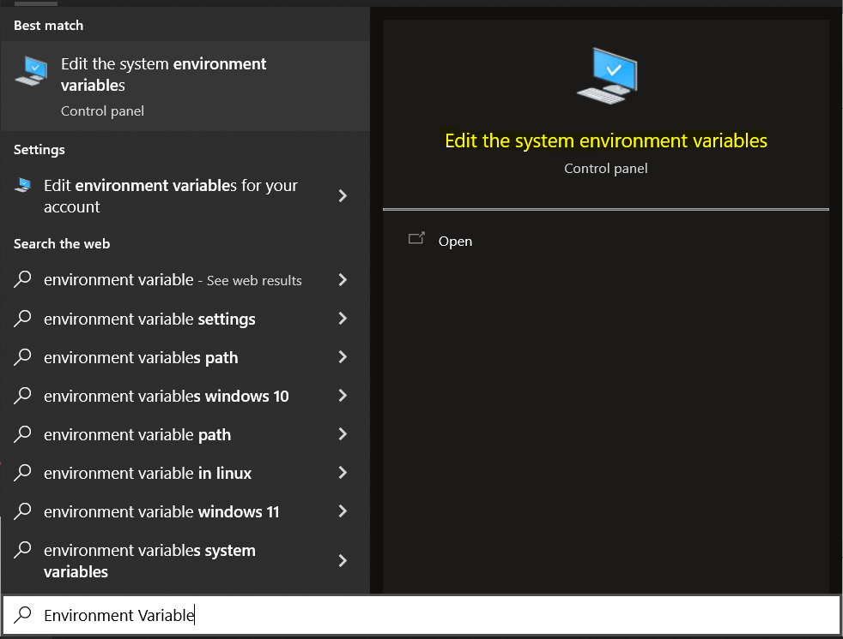

Click on the app and open it
After that you will be on the “Advance Tab of System Properties
Here Click on The Button named “Environment Variables”. This button will be at the bottom of the windows.
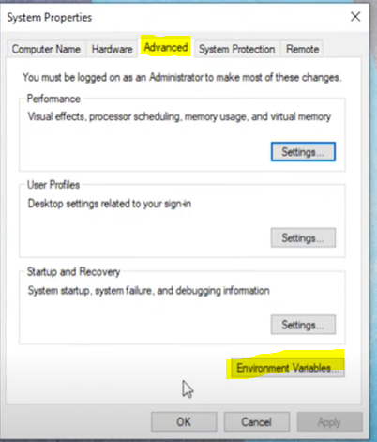
Next, come to this “System Variables” section and search variable name Paths. Just double click and open it.
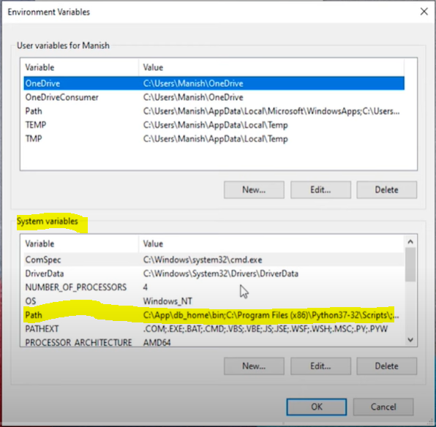
Here you will see a list of all the environment variables. Don’t delete anything only delete the location of your Oracle Home.
It will look something like below
C:\App\db_home

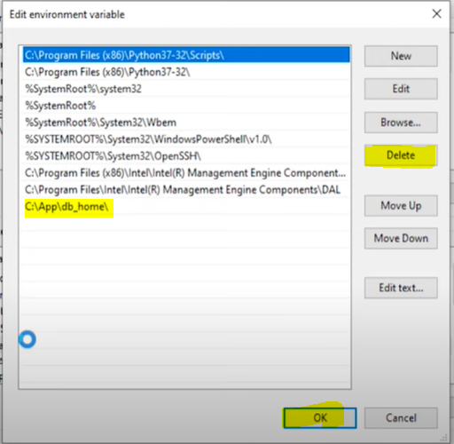

Step 2: Delete the Registries of Oracle 19c
This is a very crucial step of the entire process. While performing this step you need to be extra careful
Only delete the registries that are listed below and nothing else.

Names of Oracle Database 19c registries –
There are total 6 registries that are related to Oracle 19c. These are –
- OracleJobSchedulerORCL
- OracleOraDB19Home1MTSRecoveryService
- OracleOraDB19Home1TNSListener
- OracleRemExecServiceV2
- OracleServiceORCL
- OracleVssWriterORCL

Note - ORCL is the SID that I have assigned to my Oracle Database. This could be different for you.

Location of Oracle Database 19c registries –
Press Windows Key + R that will open your Run Dialog Box.
Inside the Run box simply write “Regedit” and press enter. That will open your Registry Editor.

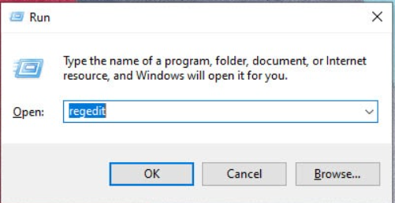

Next step is to locate the above-mentioned registries.
You can find all the above-mentioned registries at this location-
HKEY_LOCAL_MACHINE\SYSTEM\CurrentControlSet\Services\

Just go to this location and delete all the registries that are listed above. Just be careful.
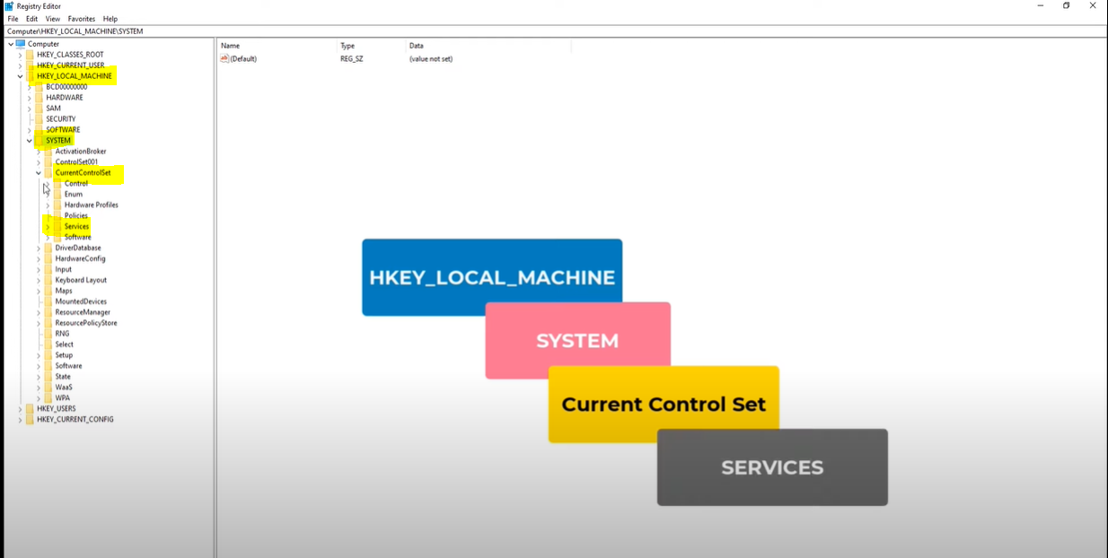
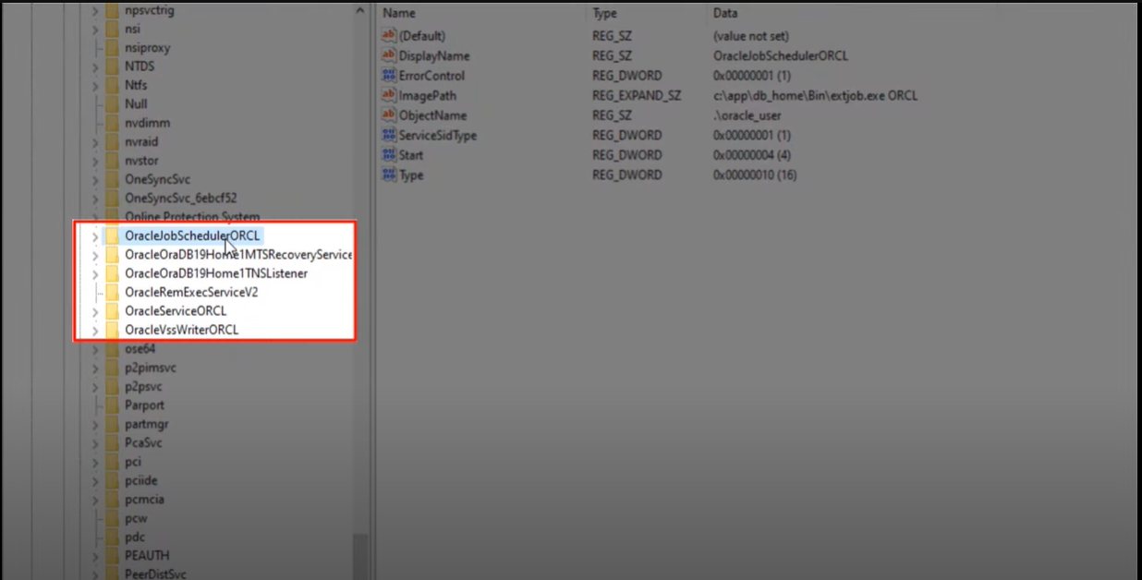

One More Registry
Along with these 6 registries there is one more that we have to delete. The name of this registry is “Oracle”. And you can find it at this location –

\HKEY_LOCAL_MACHINE\SOFTWARE
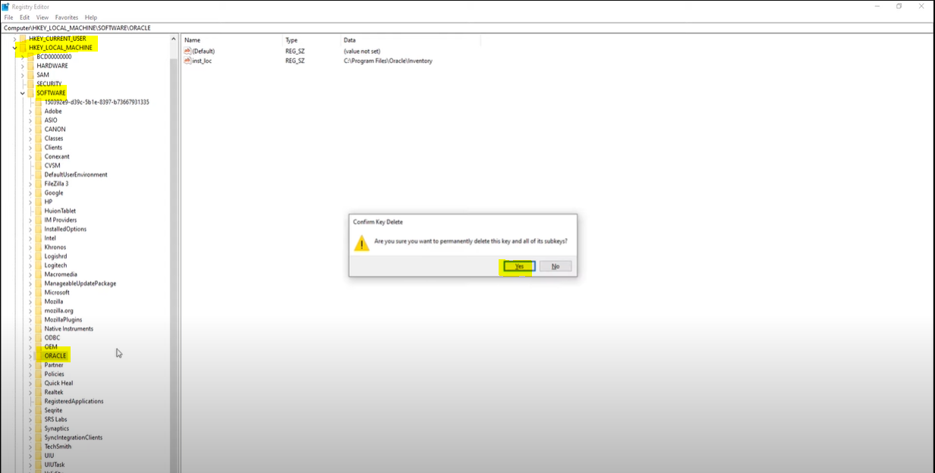

Step 3: Restart the Machine

Step 4: Delete Oracle Home Users and Groups

Where To Find Oracle 19c Windows Groups and Users –
Press Windows Key + R that will open your Run Dialog Box.
Inside the Run box simply write “lusrmgr.msc” and press enter.

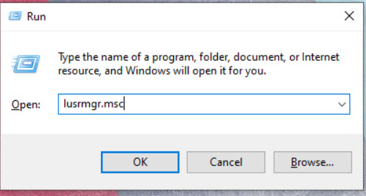

Inside “Local Users and Groups window” you will find two directories’ “Users” and “Groups”.
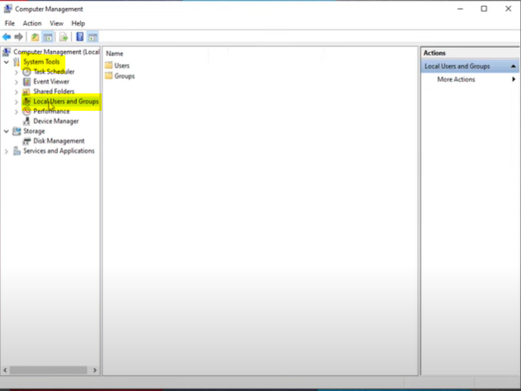

Delete the Oracle User Groups –

There are total 14 user groups, the name of these groups are as follow –
- ORA_ASMADMIN
- ORA_ASMDBA
- ORA_ASMOPER
- ORA_CLIENT_LISTENERS
- ORA_DBA
- ORA_DBSVCACCTS
- ORA_GRID_LISTENERS
- ORA_INSTALL
- ORA_OPER
- ORA_OraDB19Home1_DBA
- ORA_OraDB19Home1_OPER
- ORA_OraDB19Home1_SYSBACKUP
- ORA_OraDB19Home1_SYSDG
- ORA_OraDB19Home1_SYSKM

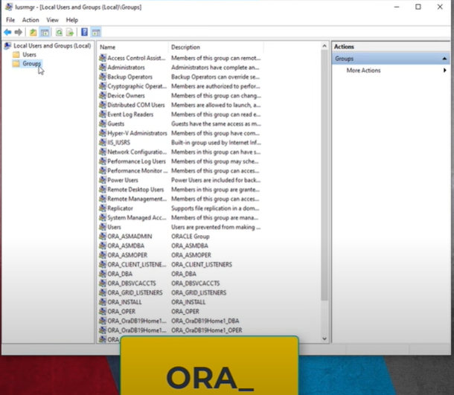
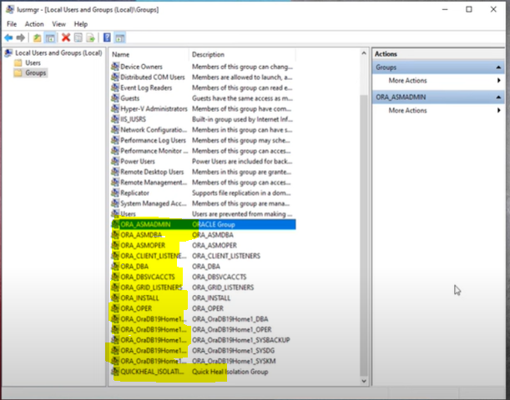

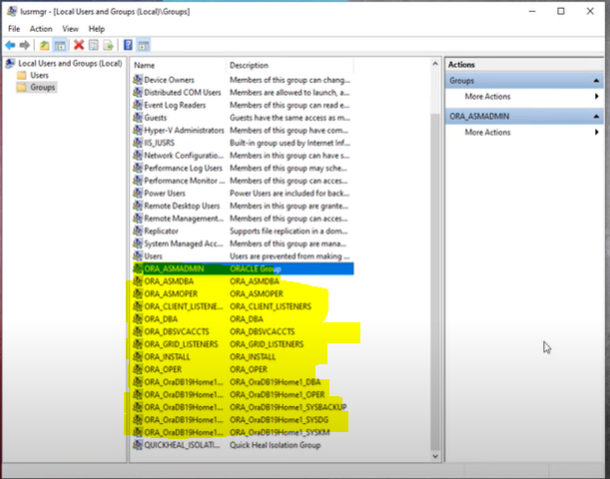

Delete the Oracle 19c’s Windows User –
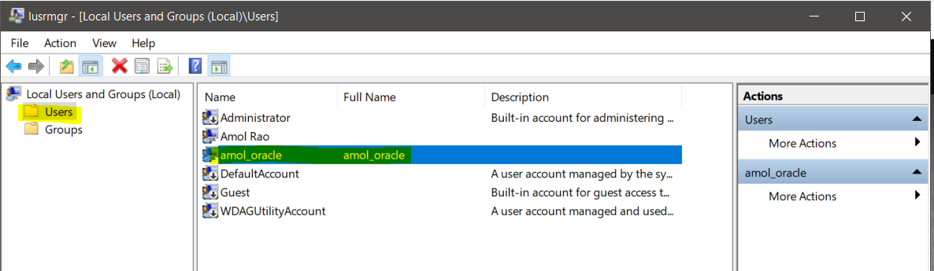

Step 5: Delete the Oracle Database 19c
Go to C drive
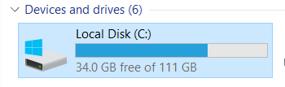
Go to App folder

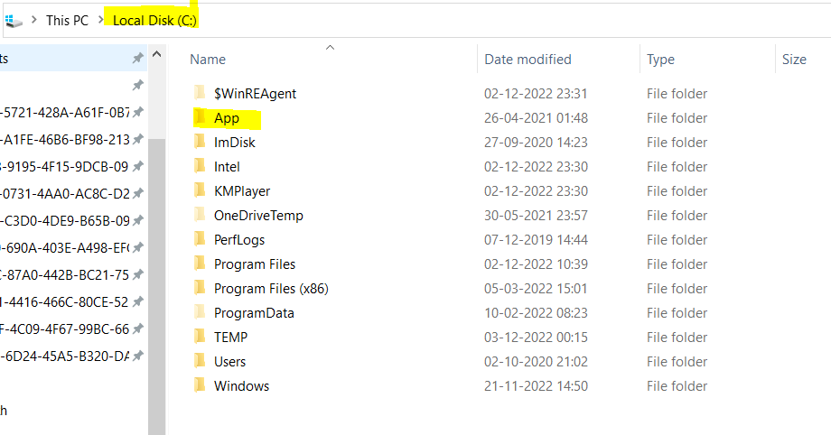
Delete all folder
Note - if you are getting any issue while delete below folder then restart your system and try to delete it again.
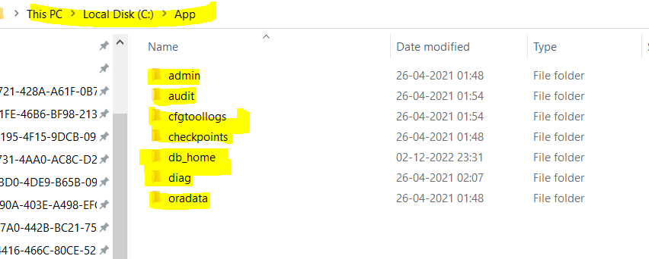

Now go to path C:\Program Files and select Oracle folder and delete it

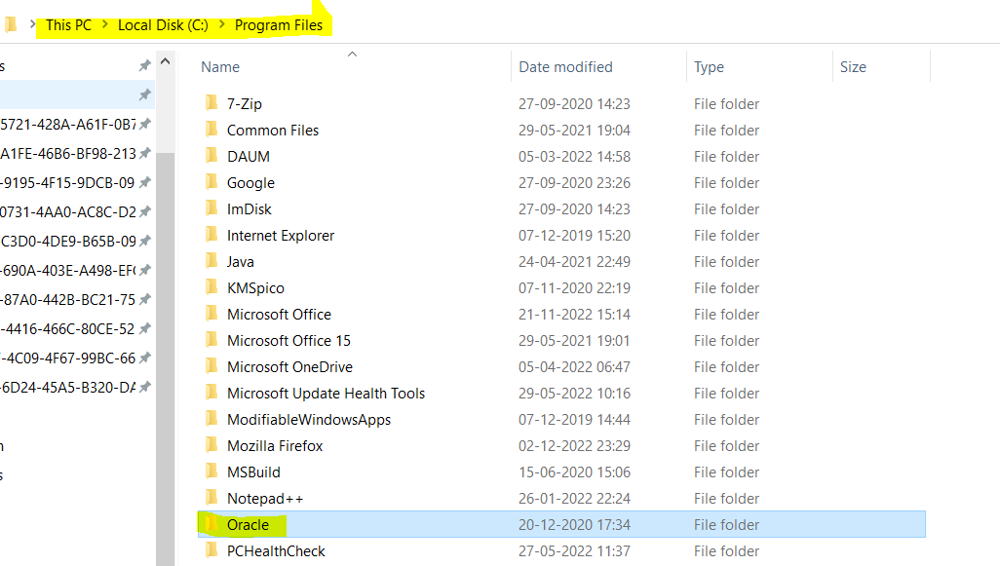

Done.

